**How to search and replace all the pattern only in 2nd line and 4th line in a closed file?**

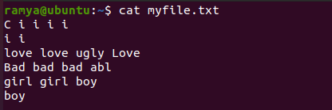

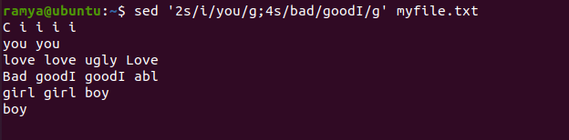

**Or**

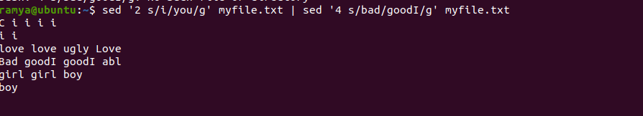

**How to delete a particular line (ex:2nd line) in a closed file?**



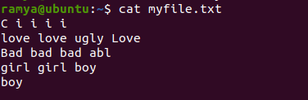

**Sed ‘2d’ myfile.txt**

**How to delete empty lines in a closed file?**

sed '/^$/d' < input file

